SIMATS ENGINEERING (SAVEETHA SCHOOL OF ENGINEERING)
Department of Computer Science and Engineering
CO2 ASSESSMENT TOOL 2 – Architecture Design Assignment

Course Code: | CSA10 / CSA1063 | Course Title: | Software Engineering
CO Assessed: | CO2 | Assessment: | Assessment Tool 2 – Architecture Design Assignment
Weightage: | 20% | Total Marks: | 25
CO2 Statement: | Perform detailed requirements analysis, design scalable architectures, and prioritize features with a focus on cross-disciplinary skills
Student Name: | Ishwariya P | Reg. No.: | 192524445
Date: | 6/8/2026 | Duration: | 60 minutes

Code of Conduct
I Ishwariya (192524445) (Name / Reg No) certify that this submission is my original work and that I have adhered to the guidelines specified for this assessment. I understand that any violation of academic integrity rules will result in disciplinary action.
Signature of the Student: _________________________
Annexure A – Architecture Design Assignment
Instructions to Students:
Each student will be assigned an individual software project problem statement. Based on the assigned problem, analyze the system requirements and design an appropriate software architecture by applying software engineering principles. Your submission should demonstrate your ability to select, justify, and evaluate a suitable architectural style.

Question
Based on your assigned problem statement, perform an Architecture Design Analysis and prepare an architecture design report by answering the following questions:

1. Analyze System Requirements
- Study the given problem statement and identify the system objectives.
- Analyze the functional and non-functional requirements that influence the software architecture.
- Identify key quality attributes such as scalability, maintainability, reliability, availability, performance, and security.

2. Select a Suitable Software Architecture
- Select an appropriate architectural style for the proposed system (e.g., Layered Architecture, Client-Server, MVC, Microservices, Event-Driven, Service-Oriented Architecture, Serverless, or Hybrid Architecture).
- Justify why the selected architecture is the most suitable for the given problem.

3. Draw the Software Architecture Diagram
- Design a clear architecture diagram illustrating the overall structure of the proposed system.
- Include all major layers/components, databases, external systems, APIs, and communication mechanisms.
- Use appropriate software architecture notations and labels.

4. Explain Components and Their Interactions
- Describe the purpose and responsibilities of each architectural component.
- Explain how the components communicate and exchange data.
- Illustrate the overall workflow of the system.

5. Discuss Quality Attributes
Evaluate how the proposed architecture addresses the following aspects:
- Scalability
- Security
- Performance
- Reliability
- Maintainability
- Availability

6. Justify Architectural Decisions
- Explain the rationale behind your architectural choices.
- Discuss the trade-offs considered while selecting the architecture.
- Explain how the chosen architecture supports future enhancements, system integration, and long-term maintainability.
Rubrics for Calculation
Evaluation Criteria | Excellent (4 Marks) | Good (3 Marks) | Satisfactory (2 Marks) | Needs Improvement (1 Mark)
System Requirement Analysis (30%) | Thoroughly analyzes the problem statement, accurately identifies functional and non-functional requirements, and clearly explains quality attributes influencing the architecture. | Analyzes most requirements with minor omissions or limited explanation. | Identifies only basic requirements with partial analysis. | Requirement analysis is incomplete, inaccurate, or lacks clarity.
Selection of Software Architecture (25%) | Selects the most appropriate architectural style with strong technical justification aligned to system requirements. | Selects a suitable architecture with reasonable justification. | Architecture is partially suitable with limited justification. | Inappropriate architecture selected or justification is missing.
Architecture Diagram and Component Design (20%) | Produces a clear, complete, and well-structured architecture diagram with all major components, interfaces, and interactions accurately represented. | Diagram is mostly complete with minor omissions or notation issues. | Diagram includes only essential components and lacks sufficient detail. | Diagram is incomplete, unclear, or technically incorrect.
Component Interaction and Quality Attribute Analysis (15%) | Clearly explains component responsibilities, interactions, and thoroughly discusses scalability, security, performance, reliability, maintainability, and availability. | Explains most components and quality attributes with minor gaps. | Provides limited explanation of interactions and addresses only some quality attributes. | Component interactions and quality attributes are poorly explained or missing.
Architectural Justification and Technical Presentation (10%) | Provides strong justification for architectural decisions, discusses trade-offs and future enhancements, and presents a well-organized, professional report. | Provides adequate justification with minor gaps; report is well organized. | Limited justification with minimal discussion of trade-offs or future scope; report needs improvement. | Justification is weak or absent; report lacks organization and technical clarity.

Criteria | Mark
System Requirement Analysis (30%) | /5
Selection of Software Architecture (25%) | /5
Architecture Diagram and Component Design (20%) | /5
Component Interaction and Quality Attribute Analysis (15%) | /5
Architectural Justification and Technical Presentation (10%) | /5
TOTAL | /25

Table of Contents
Table of Contents 1
3. Introduction 1
3.1 Background 1
3.2 Problem 1
3.3 Scope 1
3.4 Objectives 1
4. System Requirement Analysis 1
4.1 Functional Requirements 1
4.2 Non-Functional Requirements 1
4.3 Stakeholders 1
4.4 Assumptions 1
4.5 Constraints 1
4.6 Quality Attributes 1
5. Software Architecture 1
5.1 Why Chosen 1
5.2 Advantages 1
5.3 Limitations 1
5.4 Comparison with Alternative Architectures 1
6. Architecture Diagram 1
7. Components 1
7.1 Camera Layer 1
7.2 Edge Processing 1
7.3 AI Detection 1
7.4 Inventory Service 1
7.5 Analytics 1
7.6 Alert Service 1
7.7 Prediction Engine 1
7.8 API Gateway 1
7.9 Authentication 1
7.10 Dashboard 1
7.11 Database 1
7.12 Notification 1
7.13 Component Responsibilities 1
8. Component Interaction 1
9. Database Design 1
9.1 Entity Descriptions 1
9.2 Database Schema 1
10. APIs 1
11. Quality Attribute Analysis 1
11.1 Scalability 1
11.2 Security 1
11.3 Performance 1
11.4 Reliability 1
11.5 Availability 1
11.6 Maintainability 1
12. Architectural Decisions 1
14. Conclusion 1

3. Introduction

3.1 Background
Traditional retail inventory management relies heavily on periodic manual stock counts and visual shelf inspections performed by store staff. This approach is labour-intensive, error-prone, and generates inventory data that is often hours or even days out of date by the time it reaches decision makers. As retail chains scale across multiple outlets, the gap between actual shelf conditions and recorded inventory levels widens, directly affecting customer experience and revenue. Advances in computer vision, edge computing, and event-driven cloud architectures now make it feasible to continuously observe shelves using low-cost cameras and convert that visual stream into structured, actionable inventory intelligence in near real time.

3.2 Problem
Retailers currently lack a reliable, low-latency mechanism to detect stock-outs, misplaced products, and shelf disorganisation as they happen. Manual audits are infrequent and inconsistent, resulting in lost sales from out-of-stock items, poor planogram compliance, and delayed replenishment decisions. There is no unified system that captures shelf-level visual data, converts it into inventory records, and surfaces predictive alerts to store operations and category management teams without requiring additional manual effort from staff.

3.3 Scope
SmartRetail Vision covers the end-to-end pipeline required to monitor retail shelves autonomously: camera-based image capture, edge pre-processing, AI-based product and gap detection, inventory state management, analytics generation, demand and stock-out prediction, alerting, and a dashboard for store and category managers. The scope includes the backend microservices, event-driven data flow, database design, and external-facing APIs. It excludes the physical installation of camera hardware, point-of-sale integration logic beyond the sales-history feed, and mobile application development, which are treated as adjacent workstreams outside this assignment.

3.4 Objectives
- Continuously monitor shelf inventory using camera feeds with minimal manual intervention.
- Detect out-of-stock, low-stock, and misplaced product conditions with high accuracy.
- Provide near real-time inventory updates to downstream analytics and replenishment systems.
- Generate predictive insights on stock depletion and demand trends.
- Notify store staff and managers of critical shelf conditions through timely alerts.
- Deliver a scalable, secure, and maintainable architecture suitable for multi-store deployment.

4. System Requirement Analysis
Requirements for SmartRetail Vision were consolidated from stakeholder discussions and tracked using a project management board. The space below is reserved for supporting artefacts such as Trello or Jira board screenshots documenting the requirement-gathering and backlog-grooming process.
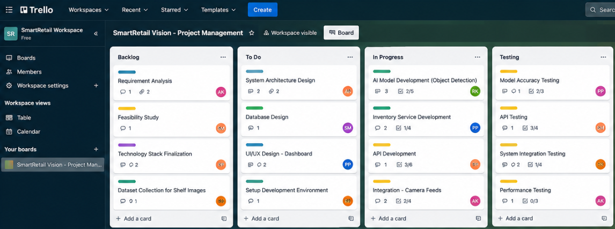

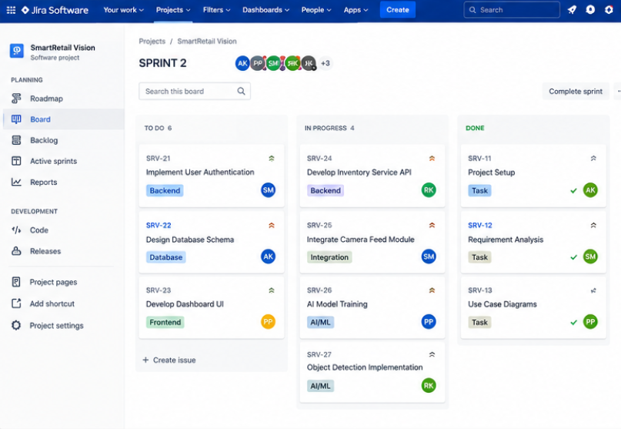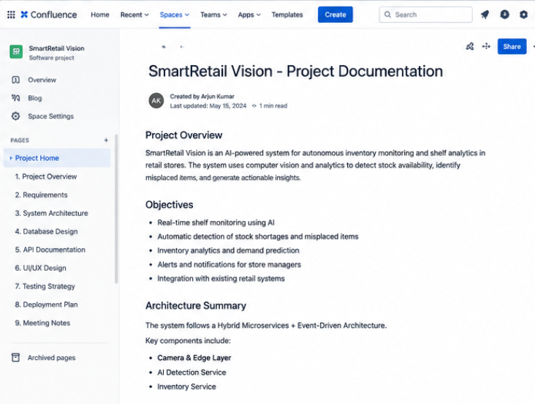4.1 Functional Requirements
ID | Requirement | Description
FR-01 | Image Capture | Capture continuous or scheduled images of shelves via networked cameras.
FR-02 | Product Detection | Detect and classify products present on the shelf using AI models.
FR-03 | Gap / Stock-out Detection | Identify empty shelf space or below-threshold stock levels.
FR-04 | Inventory Update | Update inventory records automatically based on detection results.
FR-05 | Analytics Generation | Compute shelf occupancy, restock frequency, and trend analytics.
FR-06 | Demand Prediction | Forecast stock depletion and replenishment needs using historical data.
FR-07 | Alerting | Send alerts to staff when stock-outs or anomalies are detected.
FR-08 | Dashboard Visualisation | Present inventory, analytics, and alerts on a web dashboard.
FR-09 | User Authentication | Authenticate and authorise users based on role.
FR-10 | Historical Reporting | Provide historical detection logs and sales-correlated reports.

4.2 Non-Functional Requirements
ID | Category | Requirement
NFR-01 | Performance | Detection pipeline shall process a shelf image within 2 seconds end-to-end.
NFR-02 | Scalability | System shall support horizontal scaling to 1000+ camera feeds across stores.
NFR-03 | Availability | Core services shall maintain 99.5% uptime during store operating hours.
NFR-04 | Security | All data in transit and at rest shall be encrypted; access shall be role-based.
NFR-05 | Reliability | Missed detections shall be retried via event replay without data loss.
NFR-06 | Maintainability | Services shall be independently deployable with versioned APIs.
NFR-07 | Usability | Dashboard shall present alerts and analytics in an intuitive, low-latency UI.

4.3 Stakeholders
Stakeholder | Interest / Role
Store Manager | Monitors shelf alerts and daily inventory accuracy.
Category Manager | Uses analytics and predictions for planogram and replenishment planning.
Store Associate | Acts on stock-out alerts to restock shelves.
IT / DevOps Team | Deploys, monitors, and maintains the platform infrastructure.
Retail Operations Head | Oversees multi-store performance and ROI of the system.
System Administrator | Manages user roles, access, and system configuration.
Software Development Team | Designs, builds, and evolves the platform architecture.

4.4 Assumptions
- Stores are equipped with network-connected cameras covering monitored shelf sections.
- Sufficient edge or on-premise compute is available for pre-processing camera streams.
- Product catalogue data is available and kept reasonably up to date.
- Store staff carry mobile or desktop access to receive alerts and dashboard notifications.

4.5 Constraints
- Camera placement and lighting conditions may vary across stores, affecting detection accuracy.
- Bandwidth limitations at store locations constrain raw video transmission to the cloud.
- The system must comply with data protection regulations applicable to video and customer-adjacent data.
- Budget and hardware constraints limit camera resolution and frame rate at smaller store formats.

4.6 Quality Attributes
The following quality attributes were prioritised during requirement analysis and directly influenced the architectural style selected in Section 5: Scalability, to accommodate growth from a single pilot store to a nationwide chain; Security, to protect video streams, inventory data, and user credentials; Performance, to keep detection-to-alert latency low enough for operational usefulness; Reliability, to ensure detection and inventory events are not silently lost; Availability, to keep monitoring functional during peak store hours; and Maintainability, to allow independent teams to evolve detection models, analytics, and the dashboard without destabilising the whole platform.

5. Software Architecture
SmartRetail Vision adopts a Hybrid Microservices plus Event-Driven Architecture. Core business capabilities such as inventory management, analytics, prediction, and alerting are implemented as independently deployable microservices, while communication between them is primarily asynchronous through an event backbone (for example, a message broker publishing detection, inventory, and alert events). Synchronous REST APIs are retained at the edges of the system, such as the API Gateway and dashboard queries, where request-response interaction is more natural.
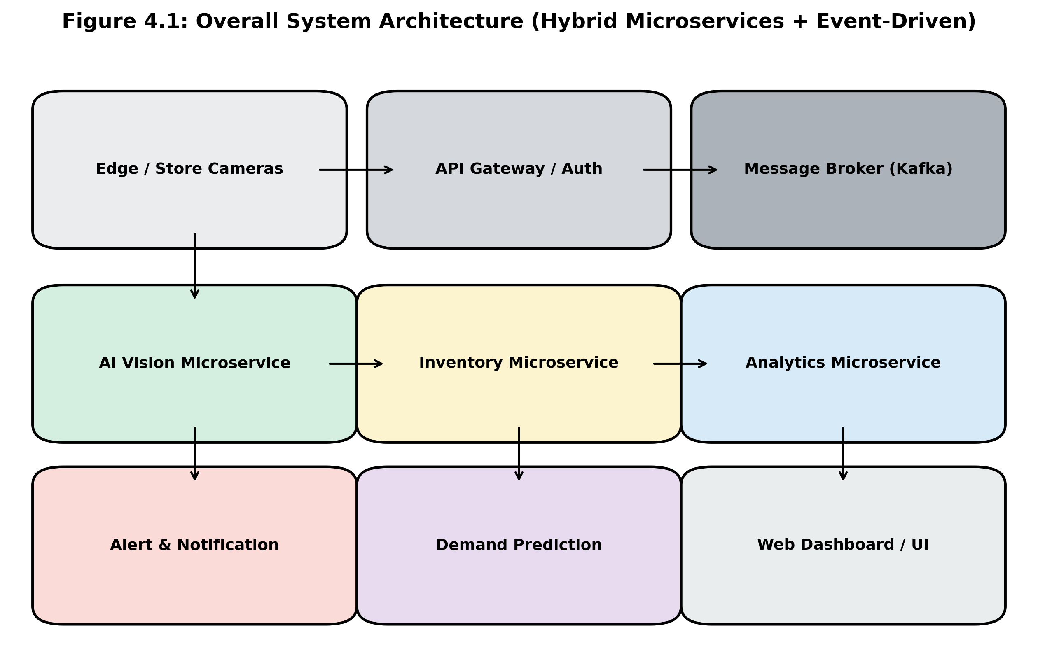

5.1 Why Chosen
The system continuously ingests high-frequency camera-derived events from many stores and must propagate state changes through several loosely coupled stages: detection, inventory update, analytics, prediction, and alerting. A pure request-response monolith would tightly couple these stages and struggle with bursty, asynchronous workloads. Event-driven communication decouples producers (for example, the AI Detection service) from consumers (for example, Inventory Service and Analytics), allowing each stage to scale and fail independently while microservices boundaries keep each capability independently developable and deployable, matching the system's need for scalability, reliability, and maintainability identified in Section 4.6.

5.2 Advantages
- Independent scaling of high-load services such as AI Detection separately from low-load services such as Authentication.
- Loose coupling through events reduces cascading failures and allows asynchronous processing of bursty camera data.
- Independent deployability enables faster iteration on AI models without redeploying the entire platform.
- Natural fit for real-time workflows spanning detection, inventory, analytics, and alerting.
- Improved fault isolation; a failure in Prediction Engine does not block Inventory Service updates.

5.3 Limitations
- Increased operational complexity from managing multiple services, message brokers, and deployment pipelines.
- Eventual consistency across services requires careful handling of stale reads in the dashboard.
- Debugging and tracing requests across asynchronous event chains is harder than in a monolith.
- Higher initial infrastructure and DevOps investment compared to simpler architectural styles.

5.4 Comparison with Alternative Architectures
Architecture | Strengths | Why Not Chosen
Layered Architecture | Simple, well-understood, clear separation of concerns. | Poor fit for asynchronous, high-throughput event flows across many stores.
MVC | Good for structuring a single application's presentation logic. | Addresses UI structuring only; does not address distributed backend scaling.
Client-Server | Straightforward request-response model, easy to reason about. | Does not scale well for continuous camera-driven event streams and multi-service workflows.
Monolithic | Simple deployment and easier initial development. | Difficult to scale detection workloads independently; slows down releases as the system grows.
Hybrid Microservices + Event-Driven (Chosen) | Independent scaling, loose coupling, real-time event propagation, fault isolation. | Selected as the best fit for the system's scale and real-time requirements.

6. Architecture Diagram
The diagram below illustrates the overall hybrid microservices and event-driven architecture of SmartRetail Vision, including the camera layer, edge processing, core microservices, the event backbone, and the client-facing dashboard.

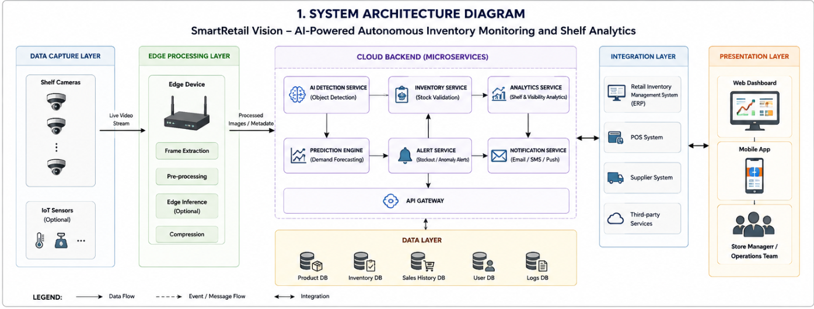7. Components

7.1 Camera Layer
Captures continuous or scheduled shelf imagery from in-store cameras and forwards raw frames to the edge processing layer.

7.2 Edge Processing
Performs local pre-processing such as frame filtering, compression, and motion-based triggering to reduce bandwidth before cloud transmission.

7.3 AI Detection
Runs computer-vision models to detect products, empty shelf space, and misplacement, publishing detection events to the event backbone.

7.4 Inventory Service
Consumes detection events and maintains authoritative shelf and product inventory state.

7.5 Analytics
Aggregates detection and inventory events into shelf occupancy trends, restock frequency, and operational metrics.

7.6 Alert Service
Evaluates inventory and analytics events against thresholds and triggers alerts for stock-outs or anomalies.

7.7 Prediction Engine
Applies historical inventory and sales data to forecast future stock depletion and replenishment needs.

7.8 API Gateway
Provides a unified, secured entry point routing external requests to the appropriate backend microservice.

7.9 Authentication
Manages user identity, login, and role-based access control across the platform.

7.10 Dashboard
Web interface presenting inventory status, analytics, predictions, and alerts to store and category managers.

7.11 Database
Persists product, inventory, detection, alert, and user data used across services.

7.12 Notification
Delivers alerts and updates to end users via channels such as email, SMS, or push notification.
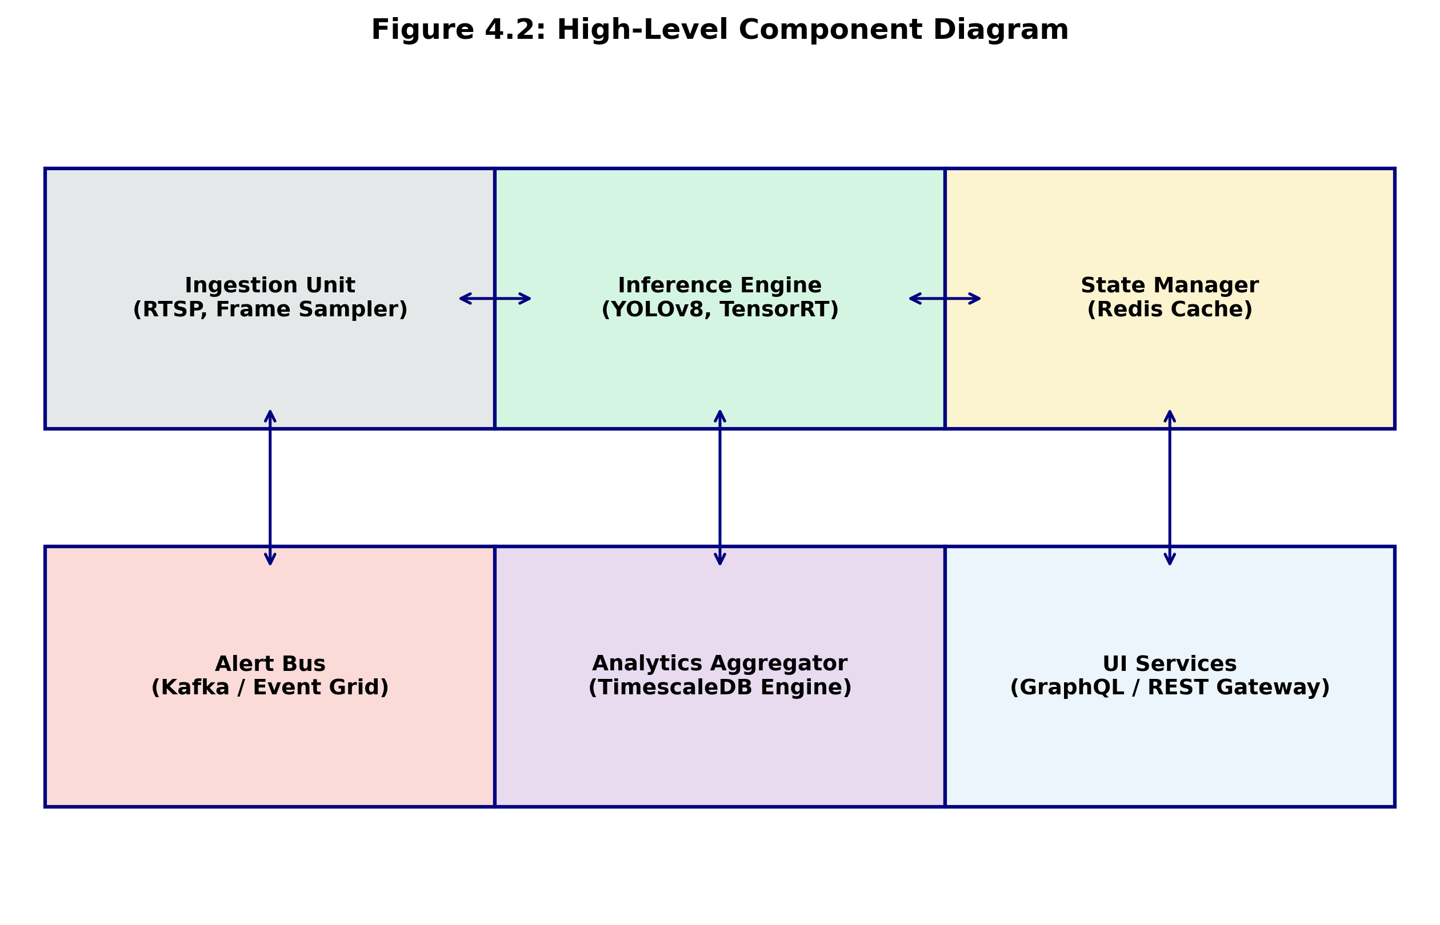

7.13 Component Responsibilities
Component | Primary Responsibility
Camera Layer | Continuous image capture from shelf-facing cameras.
Edge Processing | Local frame filtering and compression before transmission.
AI Detection | Product and gap detection using computer-vision models.
Inventory Service | Maintains authoritative real-time inventory state.
Analytics | Aggregates events into operational and trend metrics.
Alert Service | Threshold-based evaluation and alert generation.
Prediction Engine | Forecasts stock depletion and demand trends.
API Gateway | Single secured entry point and request routing.
Authentication | Identity, login, and role-based access control.
Dashboard | Visual presentation of inventory, analytics, and alerts.
Database | Persistent storage for all structured platform data.
Notification | Delivery of alerts through email, SMS, or push channels.

8. Component Interaction
The workflow begins when the Camera Layer captures a shelf image and forwards it through Edge Processing, which filters and compresses the frame before transmission. AI Detection consumes the processed frame, identifies products and empty shelf space, and publishes a detection event to the event backbone. The Inventory Service subscribes to detection events and updates the authoritative inventory state accordingly, in turn publishing an inventory-updated event.
Analytics consumes both detection and inventory events to compute occupancy and trend metrics, while the Prediction Engine consumes historical inventory and sales-history data to forecast future stock depletion. The Alert Service listens to inventory, analytics, and prediction events, evaluates them against configured thresholds, and raises alert events when a stock-out, anomaly, or predicted shortfall is detected. The Notification component consumes alert events and delivers them to store staff, while the Dashboard, accessed through the API Gateway with Authentication enforcing role-based access, queries the Database to present real-time inventory, analytics, predictions, and alerts to store and category managers.

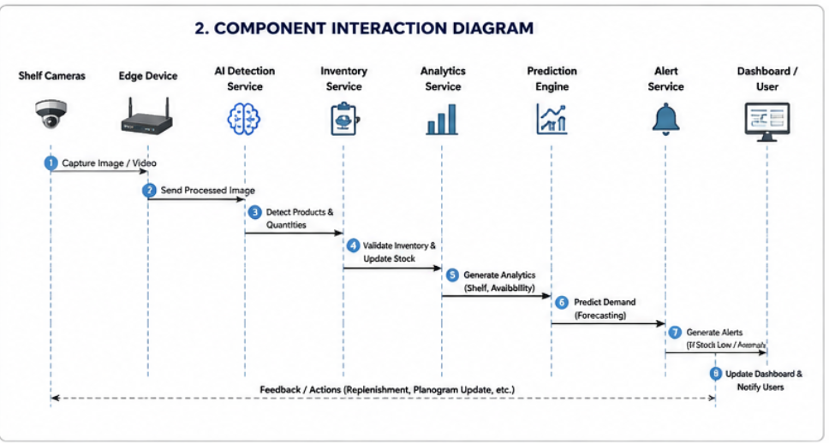9. Database Design
The database is organised around eight core entities that together capture product catalogue data, physical store layout, camera configuration, detection results, alerts, sales history, and user accounts. Primary keys uniquely identify each record, and foreign keys establish relationships between entities, for example linking Inventory records to Products and Shelves, and Detection Logs to Cameras and Shelves.

9.1 Entity Descriptions
- Products: Master catalogue of items, including SKU, name, category, and reorder threshold.
- Inventory: Current stock level per product per shelf, updated by detection-derived events.
- Shelves: Physical shelf locations within a store, including store, aisle, and section identifiers.
- Cameras: Camera devices mapped to the shelves they monitor, including status and configuration.
- Detection Logs: Raw AI detection results per image frame, including confidence and timestamp.
- Alerts: Generated alert records, including type, severity, related shelf/product, and resolution status.
- Sales History: Historical point-of-sale transaction data used to correlate and predict demand.
- Users: Platform user accounts with roles used for authentication and authorisation.

9.2 Database Schema
Table | Key Fields
Products | product_id (PK), sku, name, category, reorder_threshold
Inventory | inventory_id (PK), product_id (FK), shelf_id (FK), quantity, updated_at
Shelves | shelf_id (PK), store_id, aisle, section
Cameras | camera_id (PK), shelf_id (FK), status, config
Detection Logs | log_id (PK), camera_id (FK), shelf_id (FK), product_id (FK), confidence, timestamp
Alerts | alert_id (PK), shelf_id (FK), product_id (FK), type, severity, status, created_at
Sales History | sale_id (PK), product_id (FK), shelf_id (FK), quantity_sold, sale_date
Users | user_id (PK), name, email, role, password_hash

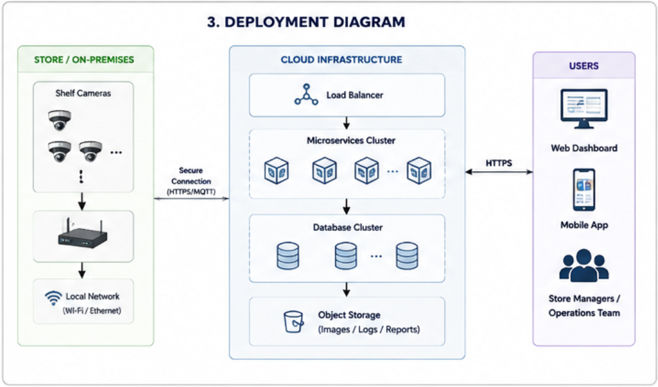10. APIs
The API Gateway exposes the following representative REST endpoints, each routed to its owning microservice. Authentication is required for all endpoints except login.
Method | Endpoint | Purpose
POST | /api/auth/login | Authenticate a user and issue an access token.
GET | /api/inventory/{shelfId} | Retrieve current inventory state for a shelf.
POST | /api/detection/events | Ingest a detection event from the AI Detection service.
GET | /api/analytics/shelf/{shelfId} | Retrieve occupancy and trend analytics for a shelf.
GET | /api/predictions/product/{productId} | Retrieve demand and stock-out predictions for a product.
GET | /api/alerts | List active and historical alerts with filters.
PATCH | /api/alerts/{alertId} | Update the status of an alert, for example acknowledge or resolve.
GET | /api/cameras/{cameraId}/status | Retrieve health and configuration status of a camera.
GET | /api/dashboard/summary | Retrieve aggregated summary data for the dashboard home view.
POST | /api/notifications/send | Trigger delivery of a notification to a target user or role.

11. Quality Attribute Analysis

11.1 Scalability
Each microservice can be scaled independently based on load; AI Detection and Inventory Service, which handle the highest event volume, can be replicated horizontally behind the event backbone without affecting lower-throughput services such as Authentication.

11.2 Security
The API Gateway centralises authentication and enforces role-based access control. Data is encrypted in transit using TLS and at rest within the database. Service-to-service communication over the event backbone is restricted to authorised producers and consumers.

11.3 Performance
Edge pre-processing reduces the volume of data sent to the cloud, and asynchronous event propagation allows detection, inventory update, and analytics stages to proceed without blocking one another, keeping end-to-end detection-to-alert latency low.

11.4 Reliability
The event backbone persists events until they are successfully processed, allowing failed consumers to retry or replay events rather than silently losing detection or inventory updates.

11.5 Availability
Stateless microservices behind the API Gateway can be deployed across multiple instances, and the event-driven design allows individual service outages to degrade gracefully rather than bringing down the entire platform.

11.6 Maintainability
Clear service boundaries and versioned APIs allow teams to update the AI Detection model, add new analytics, or modify the dashboard independently, reducing the risk and cost of ongoing platform evolution.

12. Architectural Decisions
Event-driven communication was chosen over synchronous service-to-service calls for the detection-to-alert pipeline because it decouples fast-producing services, such as AI Detection, from slower or independently-scaled consumers, such as Analytics and Prediction Engine, avoiding cascading latency. The trade-off is eventual consistency: dashboard views may briefly lag behind the true shelf state, which is acceptable given the operational nature of the alerts.
A single API Gateway was chosen to centralise authentication, rate limiting, and routing rather than requiring every service to implement these concerns individually, at the cost of introducing a component that must itself be made highly available. Microservice boundaries were drawn around business capabilities rather than technical layers, so that each service owns its data and logic end-to-end, supporting independent deployment and future extensibility, for example adding new detection models or analytics without modifying unrelated services.
For future maintainability, all inter-service contracts, both REST APIs and event schemas, are versioned, allowing new capabilities to be introduced without breaking existing consumers. This design also supports integration with adjacent systems, such as point-of-sale platforms for sales history, and future channels such as mobile applications, by extending the API Gateway and event backbone rather than restructuring the core services.

14. Conclusion
SmartRetail Vision addresses the gap between manual, infrequent shelf audits and the need for continuous, accurate inventory visibility by combining camera-based AI detection with a Hybrid Microservices and Event-Driven Architecture. The proposed design decouples image capture, detection, inventory management, analytics, prediction, and alerting into independently scalable services connected through an event backbone, while a single API Gateway and Authentication layer provide a secure, unified entry point for the dashboard and external integrations.
This architectural approach directly satisfies the quality attributes prioritised during requirement analysis: scalability to support growth across many stores and cameras, security through centralised authentication and encryption, performance through edge pre-processing and asynchronous event flow, reliability through durable event persistence, availability through stateless and independently deployable services, and maintainability through clear service boundaries and versioned contracts. The resulting design provides a technically sound and extensible foundation for autonomous inventory monitoring and shelf analytics.

